IWP EXAMPLE 1
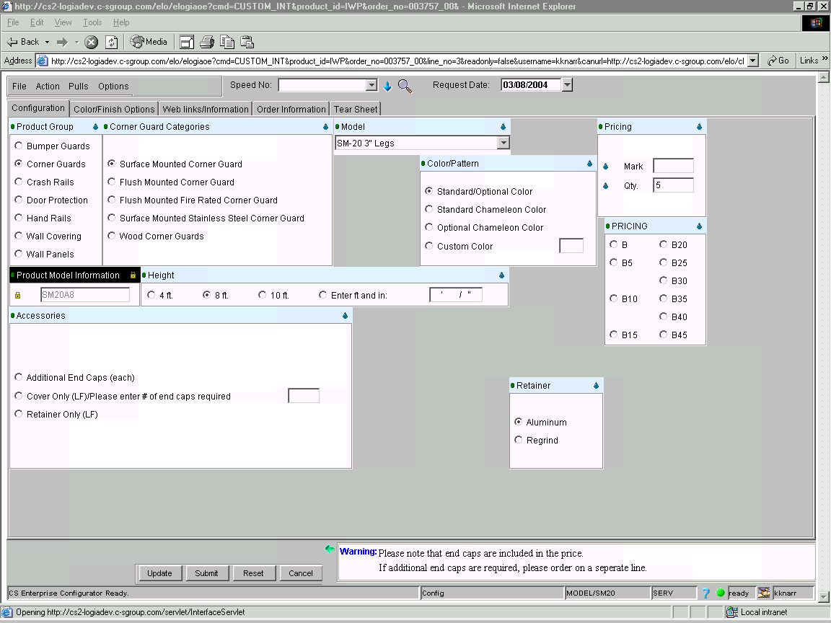
If done correctly, your price will equal $357.77.

Please note the “Pricing” block. This will not pop up until you have a quantity selected. Model will be priced at book price if no selections are made.

Reminder: The box indicating a Warning in the lower right corner is a guide on required inputs.

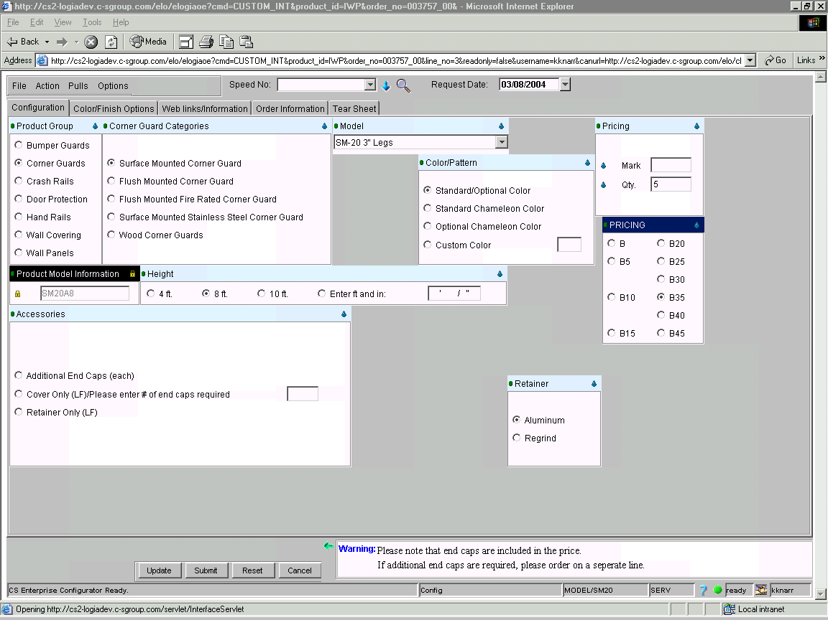
IWP EXAMPLE 2

If done correctly, your price will equal $232.55.

Model is priced at 35% off book.

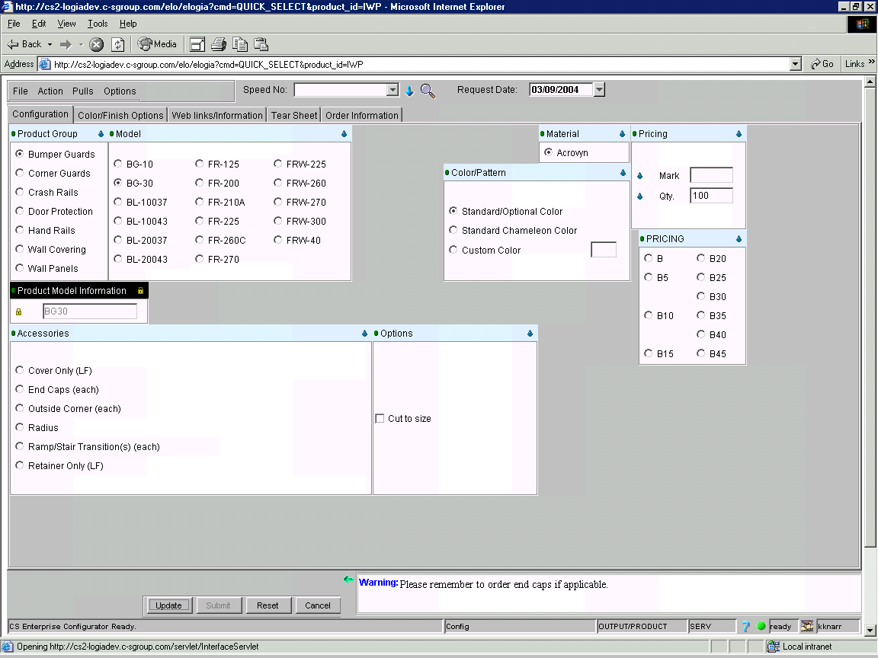
IWP EXAMPLE 3

If done correctly, your price will equal $734.99.

NOTE: You can link examples 3 and 4 by hitting File, Save Current and Create New.

IWP EXAMPLE 4

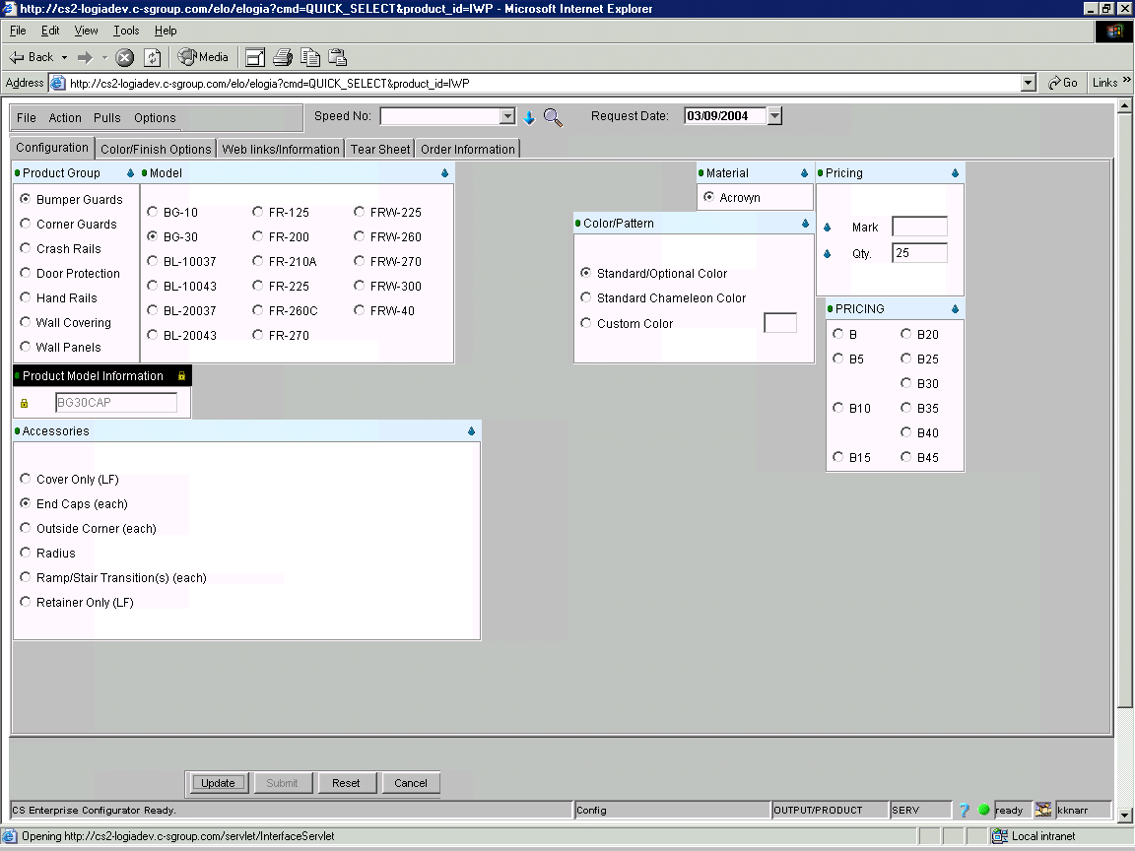

If done correctly, your price will equal $63.04.

NOTE: If you linked examples 3 and 4 with the File, Save Current and Create New option, the total will be $798.03.

IWP EXAMPLE 5

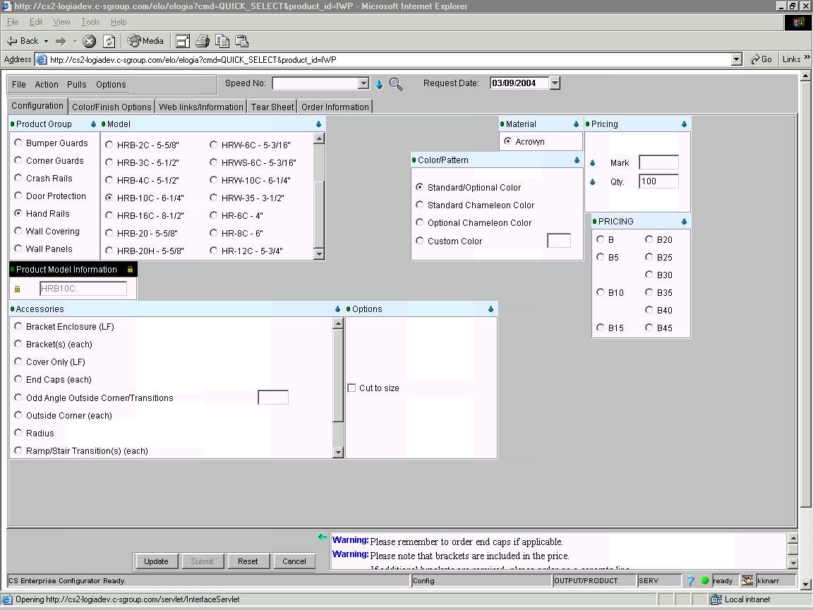

If done correctly, your price will equal $1611.75

IWP EXAMPLE 6

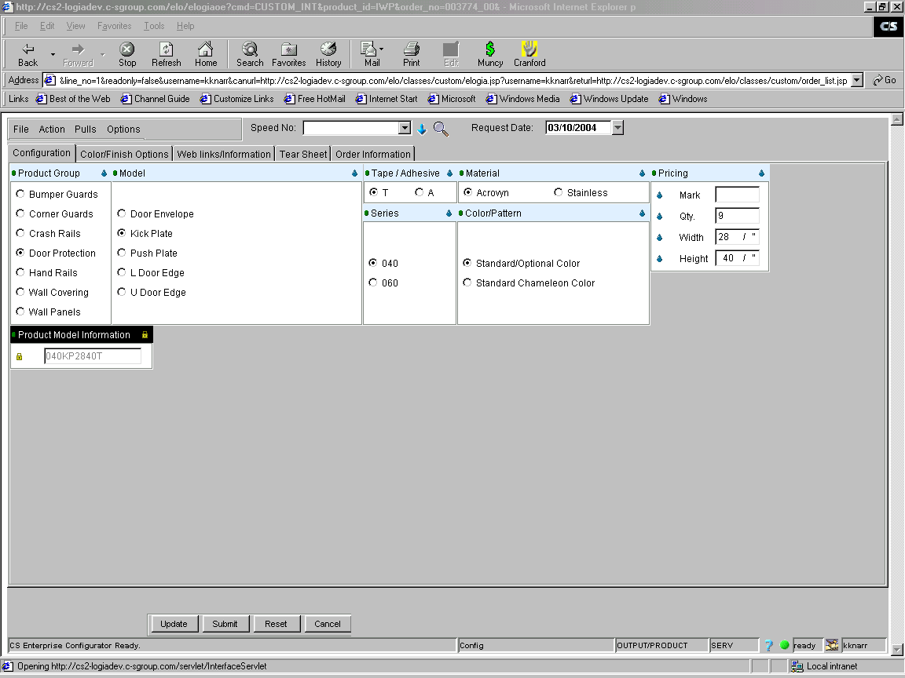
If done correctly, your price will equal $314.14.

Please note the Web Links/Information tab. This is available to show standard sizes as listed in the price book. (See next page for reference).

EXAMPLE 6 – PAGE 2

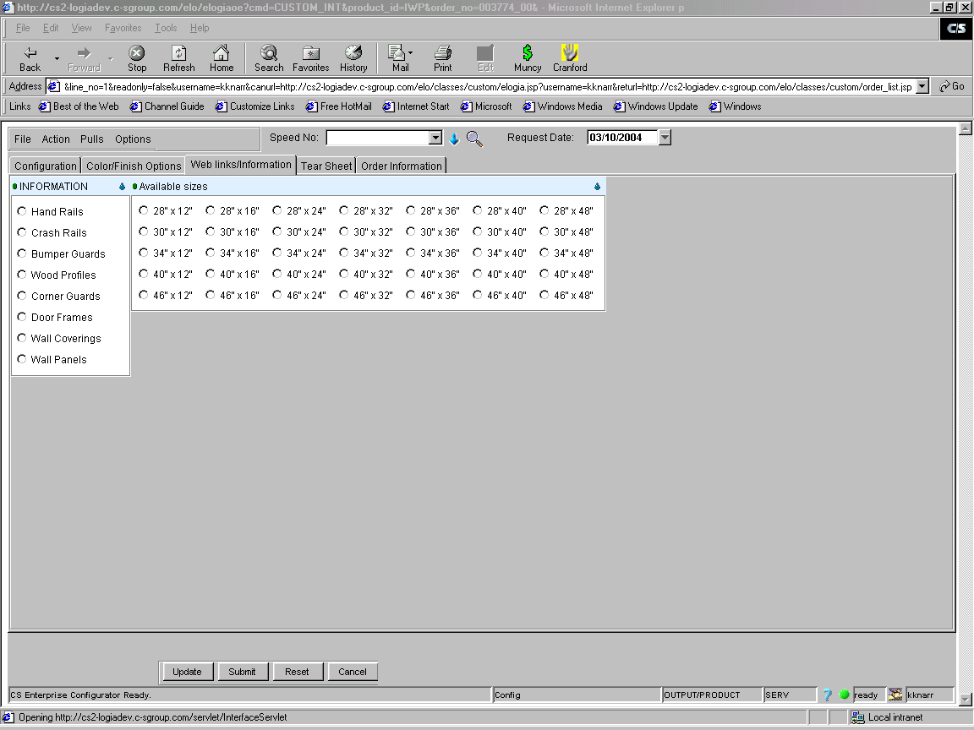

WEB LINKS/INFORMATION TAB

